ECOMMERCE Microservices Application Using JHIPSTER

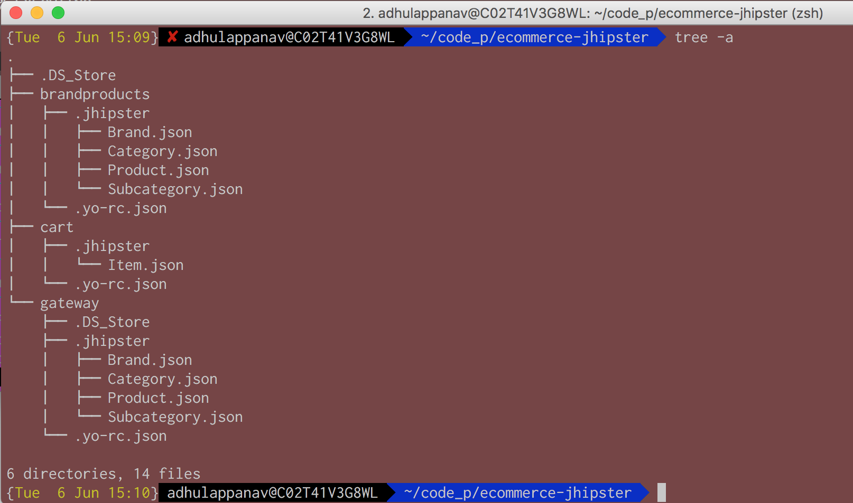

|  |  |
| --- | --- |
| {Tue 6 Jun 15:25} adhulappanav@C02T41V3G8WL  ~/code_p/ecommerce-jhipster  git clone https://github.com/adhulappanavar/ecommerce-jhipster.git | |
| Gateway  - yo jhipsterMacintosh HD:Users:adhulappanav:Desktop:Screen Shot 2017-06-06 at 3.26.17 PM.png |  | |
| BrandProducts – Microservice - 1   * yo jhipster   Macintosh HD:Users:adhulappanav:Desktop:Screen Shot 2017-06-06 at 3.28.27 PM.png |  | |
| Cart – Microservice - 2   * yo jhipster   Macintosh HD:Users:adhulappanav:Desktop:Screen Shot 2017-06-06 at 3.37.06 PM.png |  | |
| Start Registry  Macintosh HD:Users:adhulappanav:Desktop:Screen Shot 2017-06-06 at 3.39.48 PM.png |  | |
| Cart – Microservice - 2  Create the entity Item based (with the file .jhpster/Item.json)  Macintosh HD:Users:adhulappanav:Desktop:Screen Shot 2017-06-06 at 4.12.29 PM.png |  | |
| BrandProducts – Microservice - 1  Create the entities based on file .jhipster/Brands.json  Macintosh HD:Users:adhulappanav:Desktop:Screen Shot 2017-06-06 at 4.14.57 PM.pngCREATE ENTITY – BRAND  Macintosh HD:Users:adhulappanav:Desktop:Screen Shot 2017-06-06 at 4.16.21 PM.png |  | |
| CREATE ENTITY – CATEGORY  Macintosh HD:Users:adhulappanav:Desktop:Screen Shot 2017-06-06 at 4.17.51 PM.png |  | |
| CREATE ENTITY – SUBCATEGORY  Macintosh HD:Users:adhulappanav:Desktop:Screen Shot 2017-06-06 at 4.18.43 PM.png |  | |
| CREATE ENTITY – PRODUCT  Macintosh HD:Users:adhulappanav:Desktop:Screen Shot 2017-06-06 at 4.19.14 PM.png |  | |
| COMPILE & RUN BRANDPRODUCTS Microservie using ./gradlew  ..  Macintosh HD:Users:adhulappanav:Desktop:Screen Shot 2017-06-06 at 4.22.03 PM.png  ..Macintosh HD:Users:adhulappanav:Desktop:Screen Shot 2017-06-06 at 4.22.21 PM.png  … |  | |
| Create UI Elements on Gateway for Item from Cart Microservice  yo jhipster:entity Item  Enter the path of microservice  /Users/adhulappanav/code_p/ecommerce-jhipster/cart  ..Macintosh HD:Users:adhulappanav:Desktop:Screen Shot 2017-06-06 at 4.26.13 PM.png  ..  Macintosh HD:Users:adhulappanav:Desktop:Screen Shot 2017-06-06 at 4.26.33 PM.png… |  | |
| Create UI Elements on Gateway for BRAND from BRANDPRODUCT Microservice  Note : Since the .json files for these are already in present in .jhipster directory, it will not ask for path |  | |
| yo jhipster:entity Brand  Macintosh HD:Users:adhulappanav:Desktop:Screen Shot 2017-06-06 at 4.32.57 PM.png |  | |
| Macintosh HD:Users:adhulappanav:Desktop:Screen Shot 2017-06-06 at 4.33.13 PM.png |  | |
|  |  | |
| yo jhipster:entity Category  Note : We will have WARNING for Product files as it is not yet generated. This will be done in the next couple of commands |  | |
| Macintosh HD:Users:adhulappanav:Desktop:Screen Shot 2017-06-06 at 4.34.23 PM.png |  | |
| Macintosh HD:Users:adhulappanav:Desktop:Screen Shot 2017-06-06 at 4.34.37 PM.png |  | |
| yo jhipster:entity Subcategory |  | |
| Macintosh HD:Users:adhulappanav:Desktop:Screen Shot 2017-06-06 at 4.36.36 PM.png |  | |
| Macintosh HD:Users:adhulappanav:Desktop:Screen Shot 2017-06-06 at 4.36.52 PM.png |  | |
| yo jhipster:entity Product  Macintosh HD:Users:adhulappanav:Desktop:Screen Shot 2017-06-06 at 4.41.43 PM.png |  | |
| Macintosh HD:Users:adhulappanav:Desktop:Screen Shot 2017-06-06 at 4.41.54 PM.png |  | |
|  |  | |
| COMPILE AND RUN GATEWAY using ./gradlew  Macintosh HD:Users:adhulappanav:Desktop:Screen Shot 2017-06-06 at 4.44.20 PM.png |  | |
| Macintosh HD:Users:adhulappanav:Desktop:Screen Shot 2017-06-06 at 4.44.32 PM.png |  | |
|  |  | |
| Start the CART Microservice with Item Entity as well  Macintosh HD:Users:adhulappanav:Desktop:Screen Shot 2017-06-06 at 4.49.00 PM.png |  | |
| Macintosh HD:Users:adhulappanav:Desktop:Screen Shot 2017-06-06 at 4.49.14 PM.png |  | |
|  |  | |
| Check REGISTRY at - <http://localhost:8761/#/>  Macintosh HD:Users:adhulappanav:Desktop:Screen Shot 2017-06-06 at 4.49.59 PM.png |  | |
|  |  | |
| Check the App at localhost:8080  Macintosh HD:Users:adhulappanav:Desktop:Screen Shot 2017-06-06 at 4.51.03 PM.png |  | |
|  |  | |
|  |  | |
|  |  | |